Andmevoo skeemid

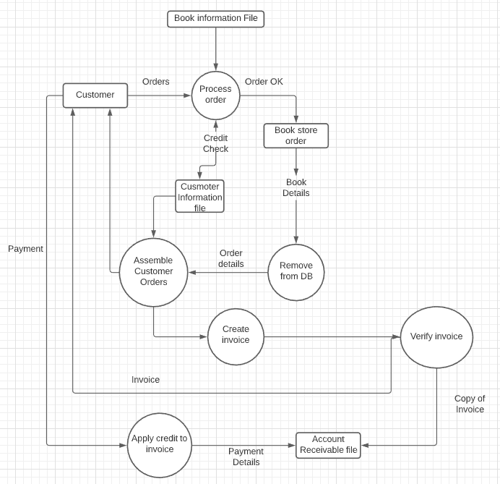

First, incoming orders are checked for correct book titles, author's names, and other information and then batched into other book orders from the same bookstore. Also, the credit status of each book store is checked before shipment is authorized. The details of the order are normally available in a special file or data store, called "Bookstore Orders".